OPERATORS And CONDITION QUESTIONS
1. Check for Even AND Positive Number
Write a Scala function to check if a given number is both even and positive.
Sample Data: Number: 28
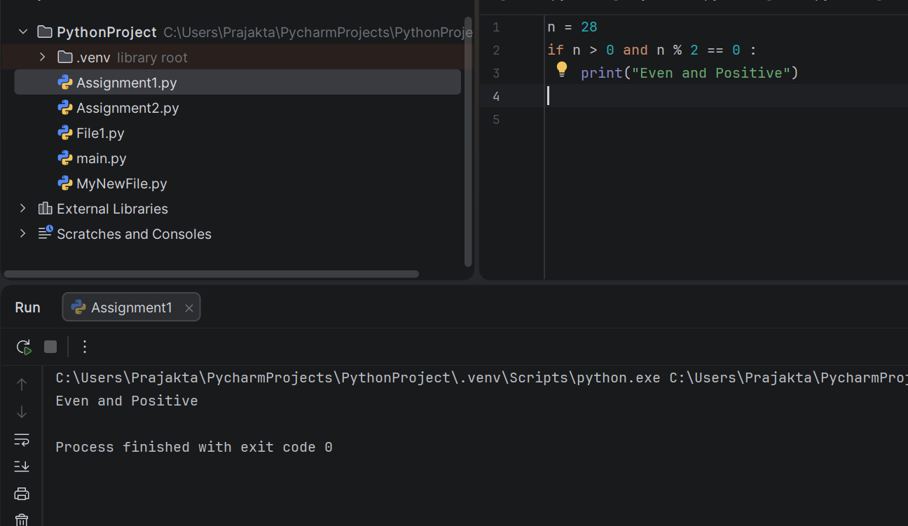
*************************************************************
2. Range Check with OR
Determine if a given value is either less than -10 or greater than 10.
Sample Data: Value: 13
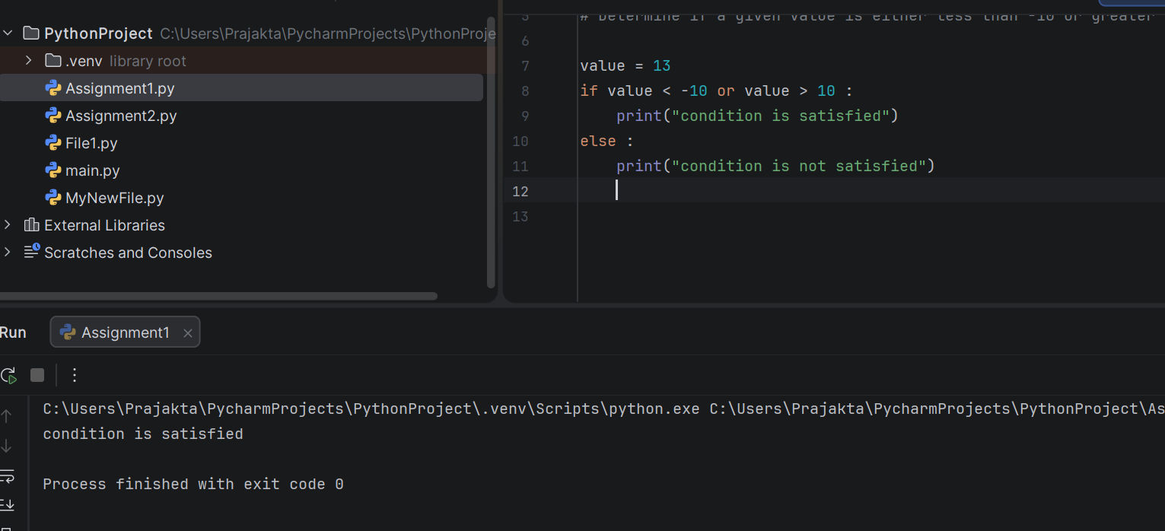
*************************************************************
3. Odd Number Check with AND
Check if a number is odd and not divisible by 3.
Sample Data: Number: 17
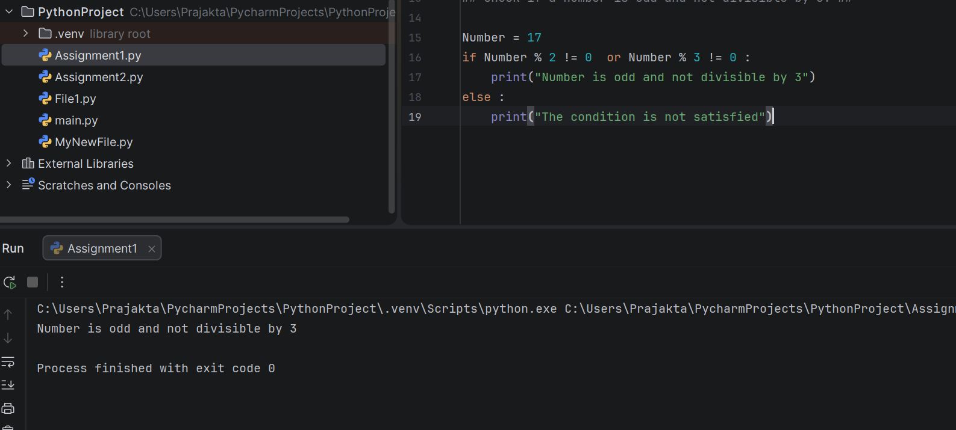
*************************************************************
4. Divisibility by 4 OR 6
Check if a number is divisible by either 4 or 6. Sample Data: Number: 36
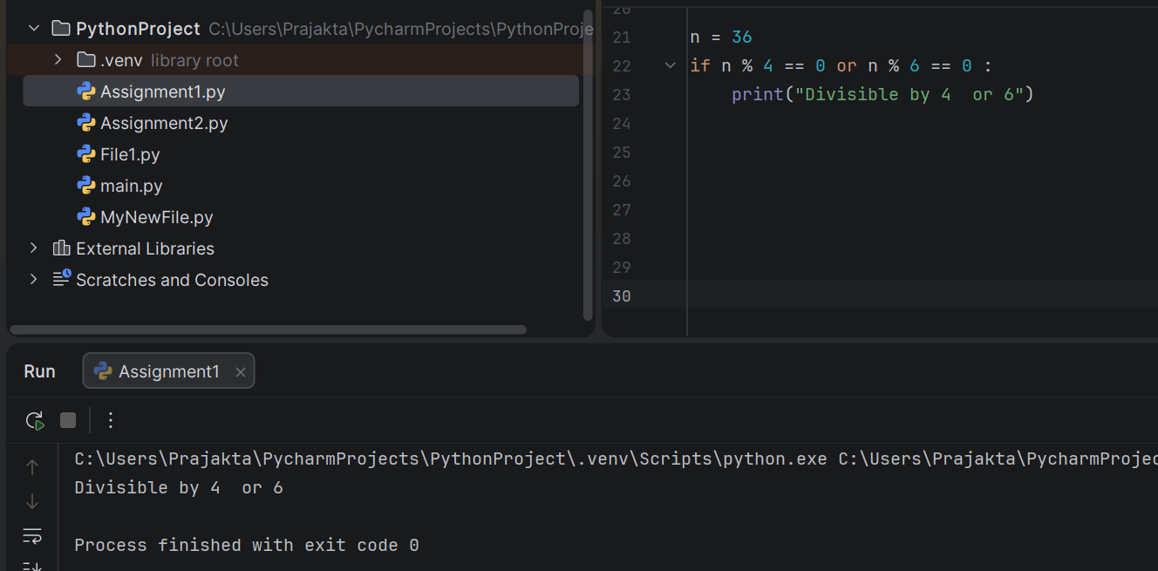
*************************************************************
5. Eligibility for Voting OR Driving
Check if a person is eligible to vote (age ≥ 18) or drive (age ≥ 16).
Sample Data: Age: 17
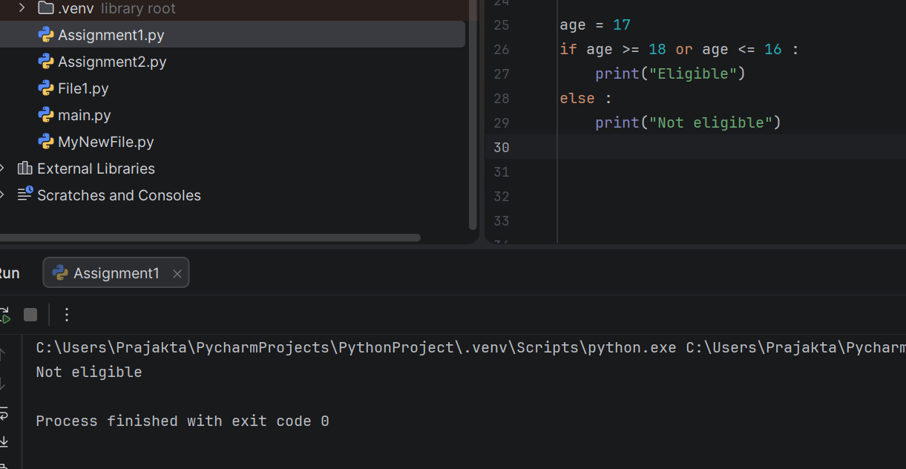
*************************************************************
6. Multiple Range Check
Check if a number is in the range [1, 10] or [20, 30].
Sample Data: Number: 8
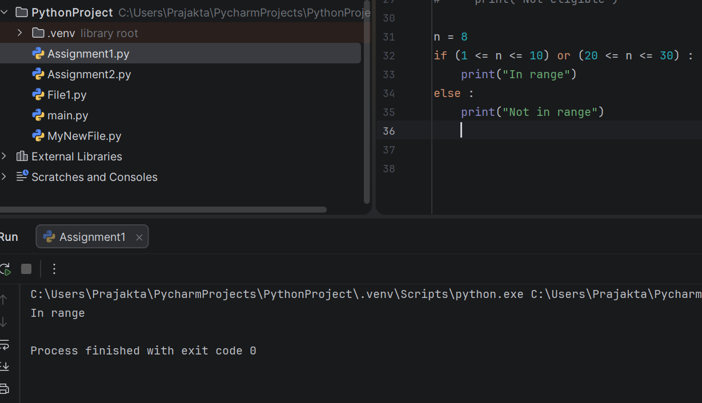
*************************************************************
7. Check for Negative AND Odd Number
Check if a number is both negative and odd.
Sample Data: Number: -15
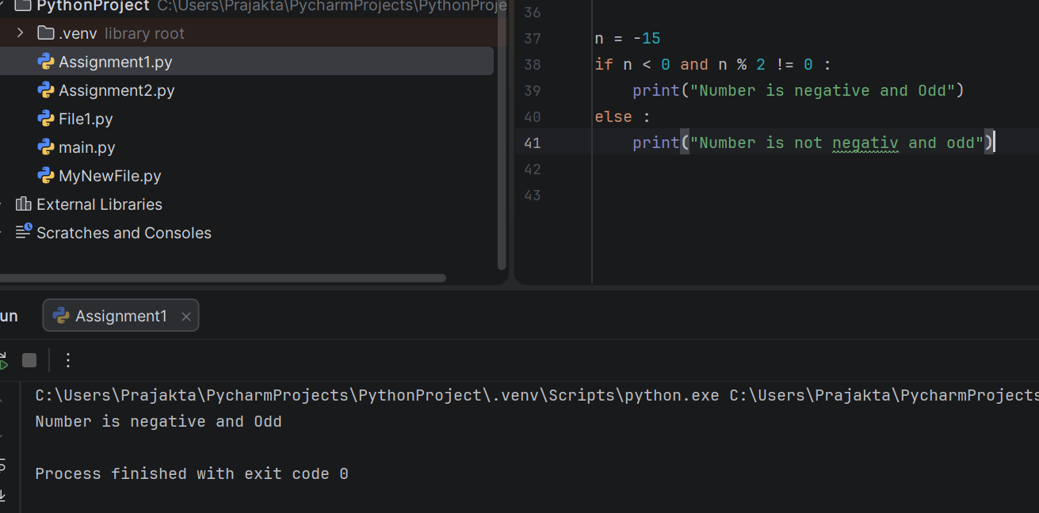
*************************************************************
8. Eligibility for Senior Discount OR Student Discount
Check if age > 60 or age < 25. Sample Data: Age: 22
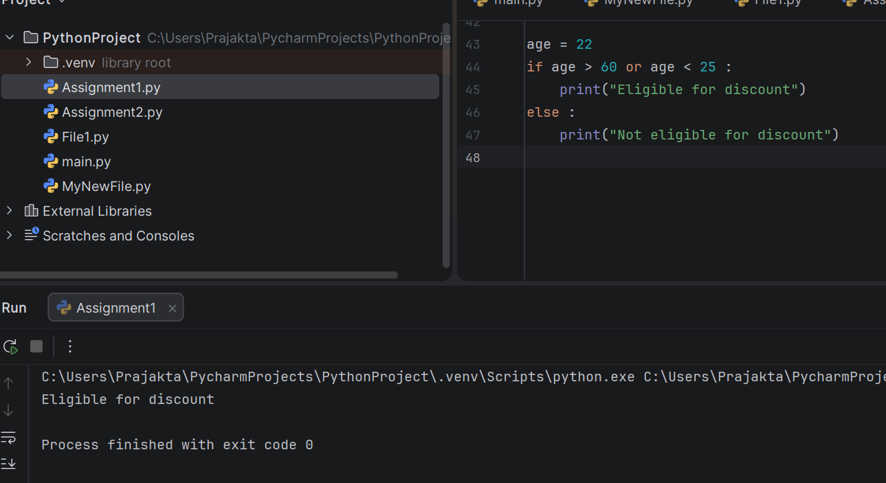

9. Divisibility by 5 AND 7. Check if a number is divisible by both 5 and 7. Sample Data: Number: 70
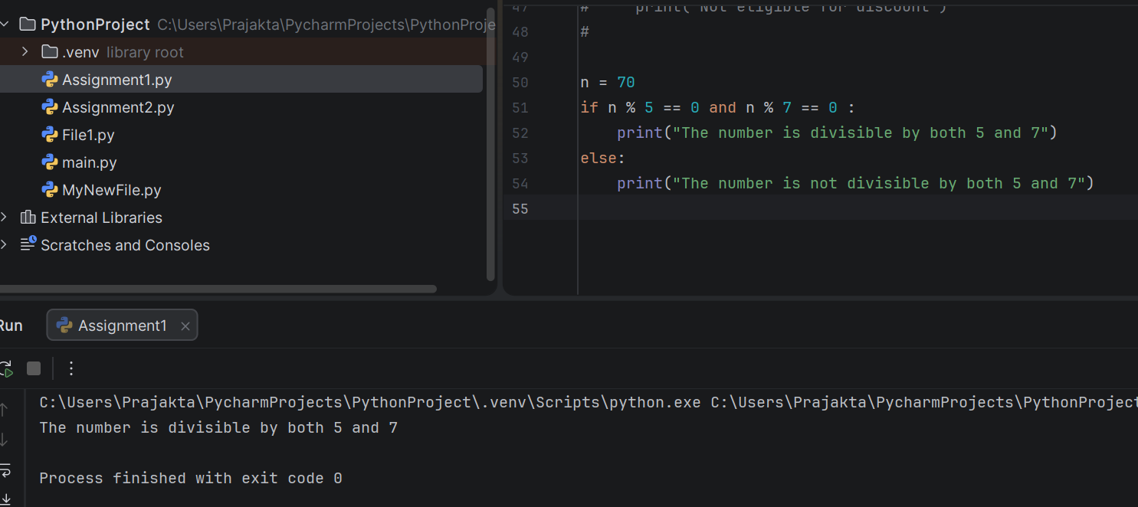
*************************************************************
10. Check for Non-Negative OR Even Number
Check if a number is either non-negative or even.
Sample Data: Number: -3
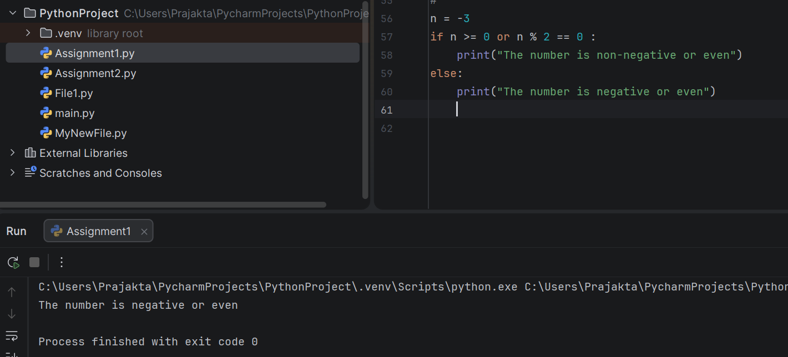
*************************************************************
11. Check for Prime AND Odd Number
Check if a number is both prime and odd. Sample Data: Number: 13w
************************************************************
12. Eligibility for Discount OR Free Shipping. Check if purchase > 150 or purchase > 100. Sample Data: Purchase Amount: 155
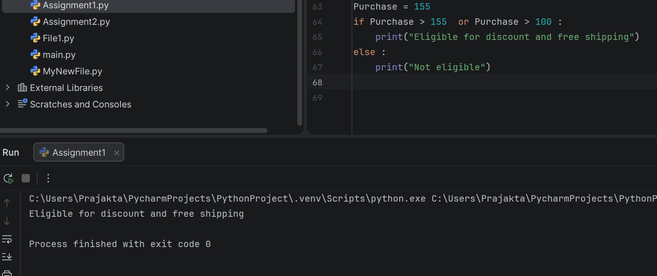
*************************************************************
13. Divisibility by 3 OR 8. Check if a number is divisible by either 3 or 8. Sample Data: Number: 16
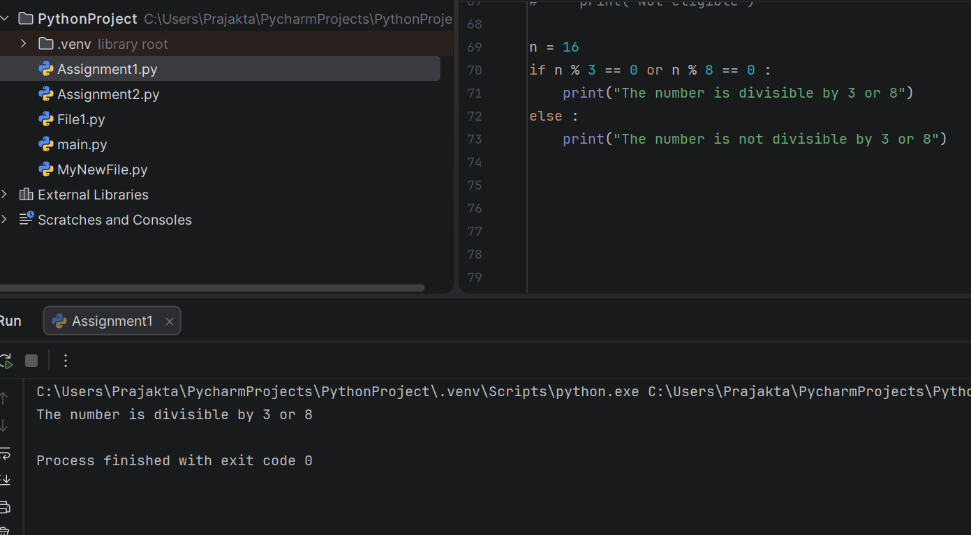
*************************************************************
14. Check for Non-Positive AND Even Number Check if a number is both non-positive and even. Sample Data: Number: 0

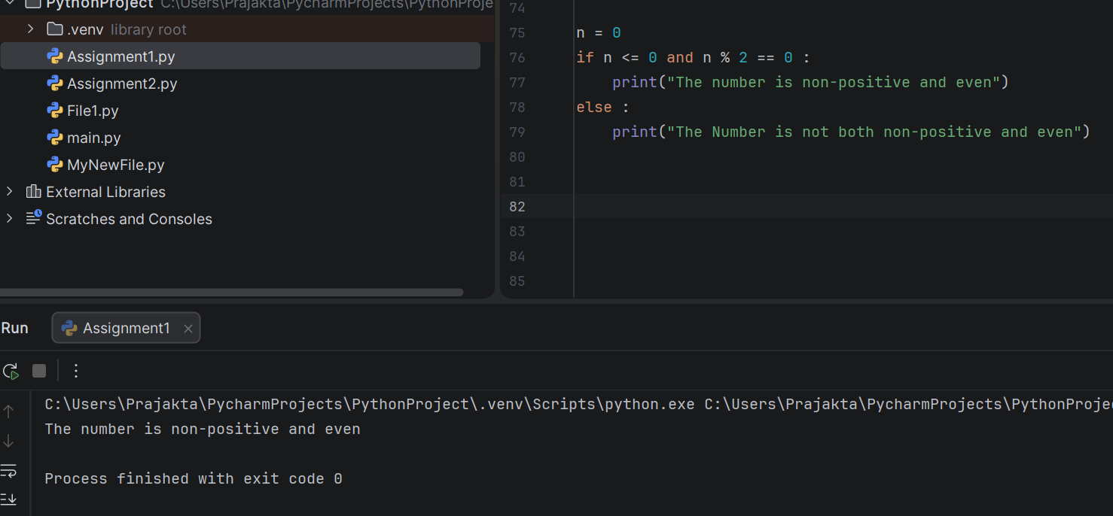
*************************************************************
15. Age Group Classification with AND. Classify as child (<13), teen (13–19), adult (≥20). Sample Data: Age: 19
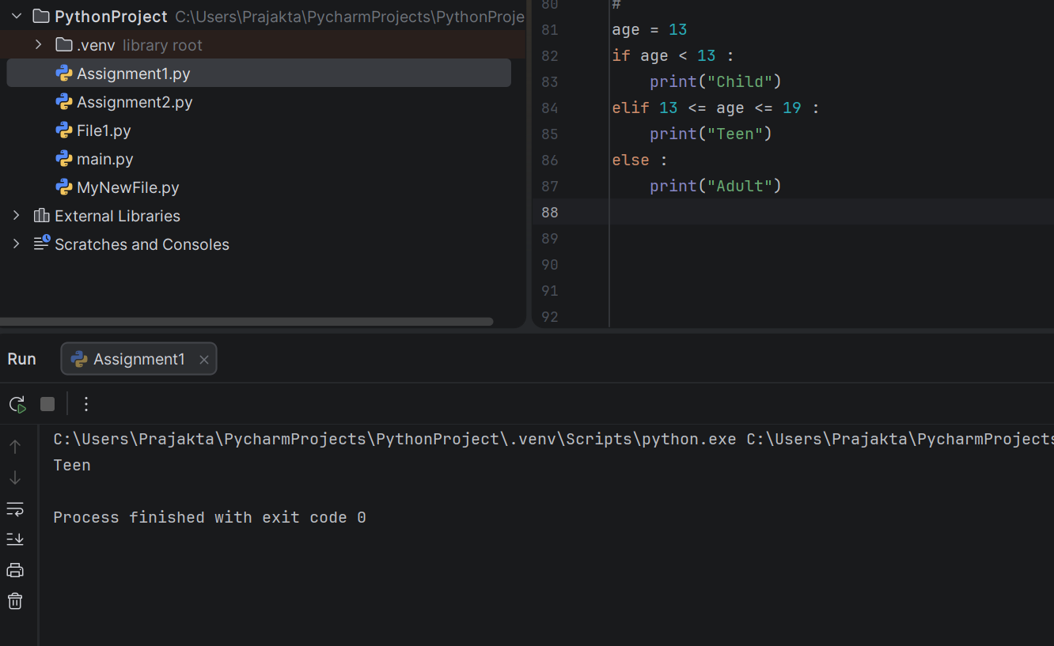
*************************************************************
16. Check for Divisibility by 2 OR 5. Check if a number is divisible by either 2 or 5.
Sample Data: Number: 40
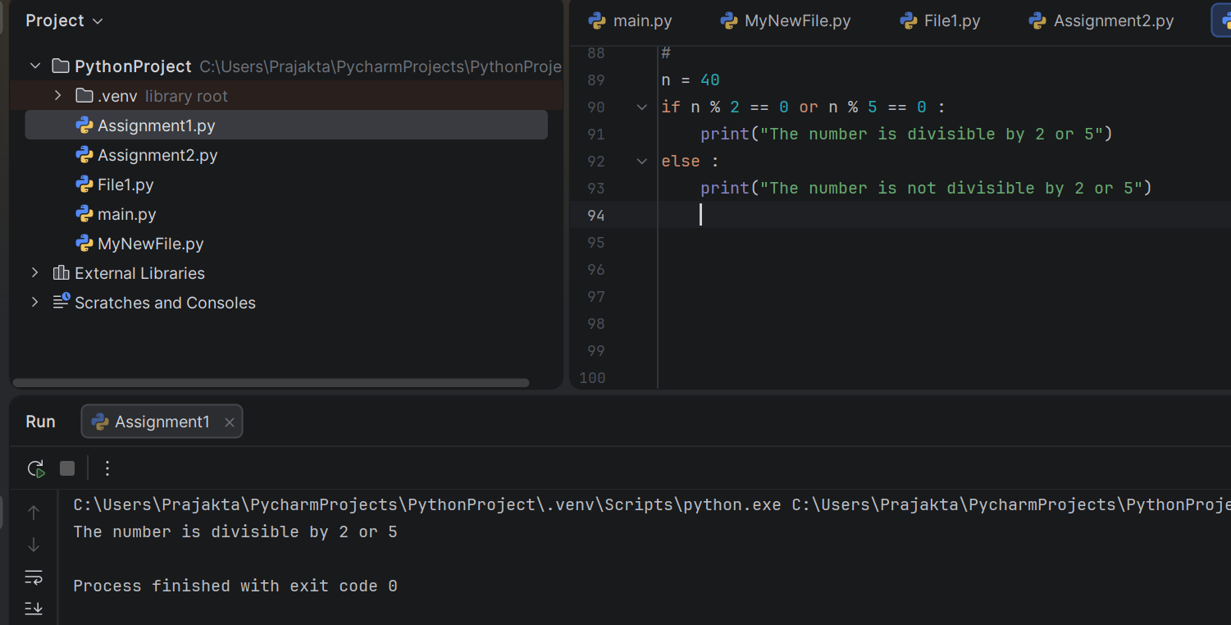
*************************************************************
17. Eligibility for Senior Discount AND Student Discount
Check if age > 60 and age < 25 (impossible case). Sample Data: Age: 18
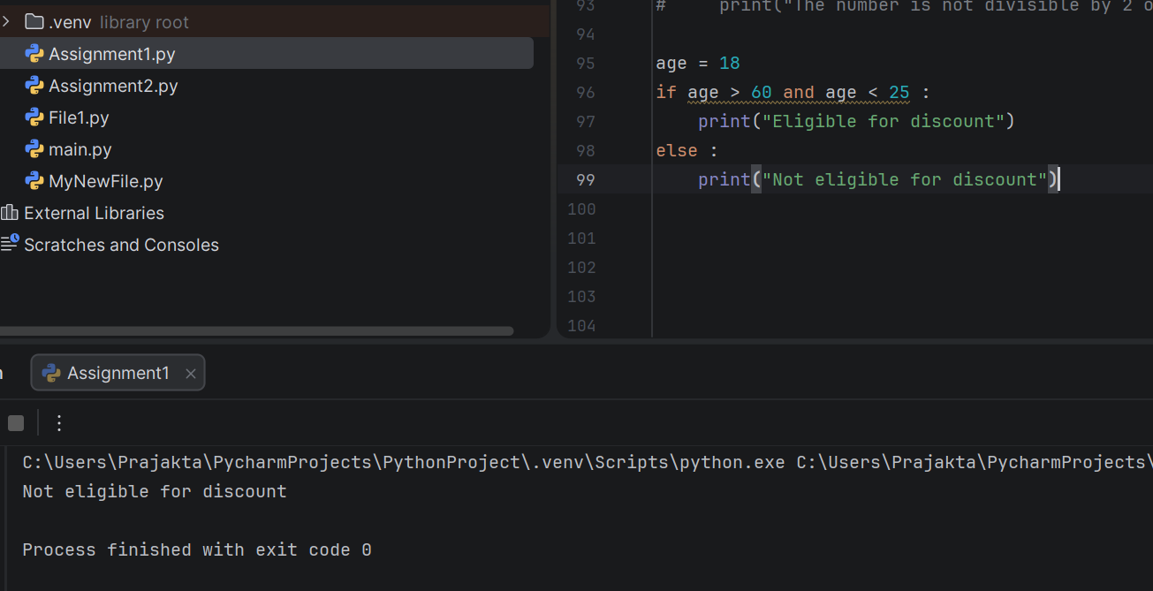
*************************************************************
18. Check for Multiple of 3 AND 7. Check if a number is divisible by both 3 and 7.
Sample Data: Number: 42
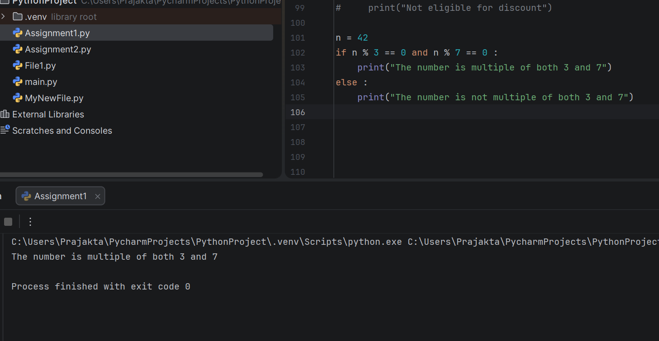
*************************************************************
19. Divisibility by 5 OR 9. Check if a number is divisible by either 5 or 9. Sample Data: Number: 27
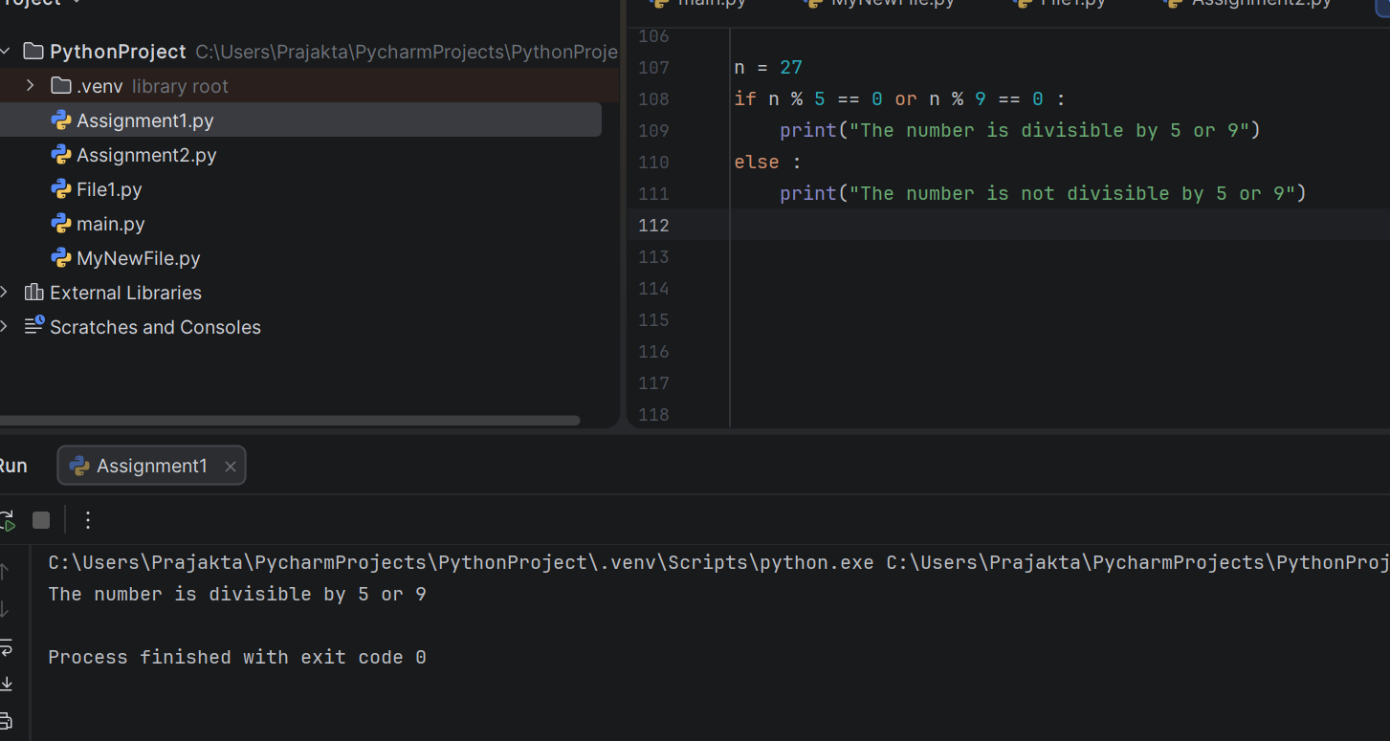
*************************************************************
20. Check for Odd AND Not Divisible by 4. Check if a number is odd and not divisible by 4.
Sample Data: Number: 9

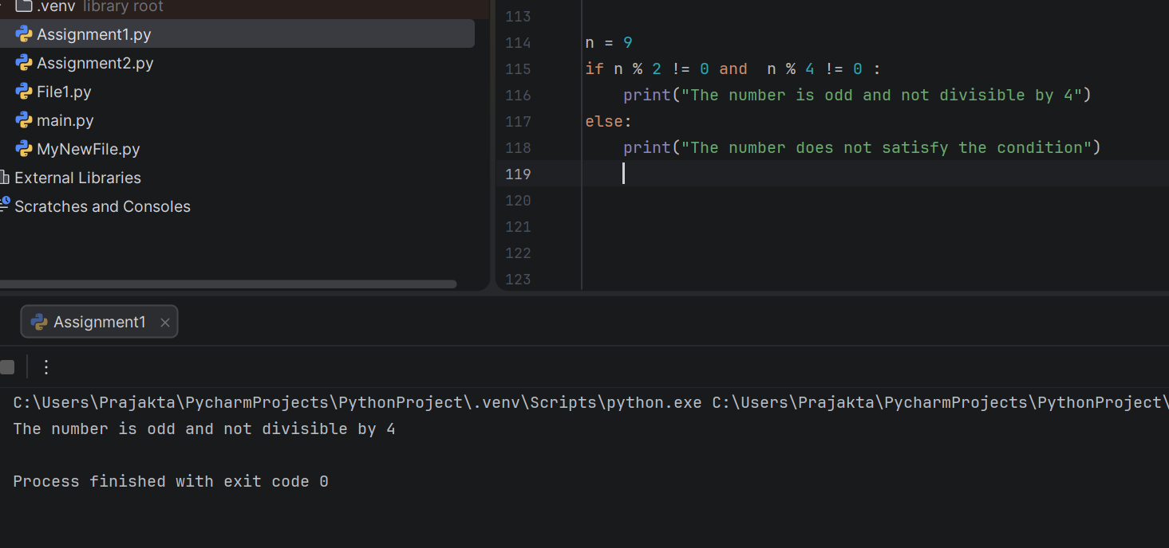
*************************************************************
21. Check for Divisibility by 3 AND 5. Check if a number is divisible by both 3 and 5.
Sample Data: Number: 90
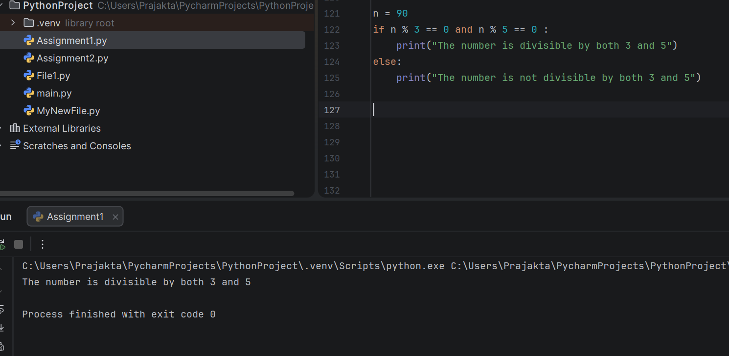
*************************************************************
22. Eligibility for Discount OR Membership Benefits. Check if purchase > 200 or has loyalty card. Sample Data: Purchase Amount: 140, Loyalty Card: true
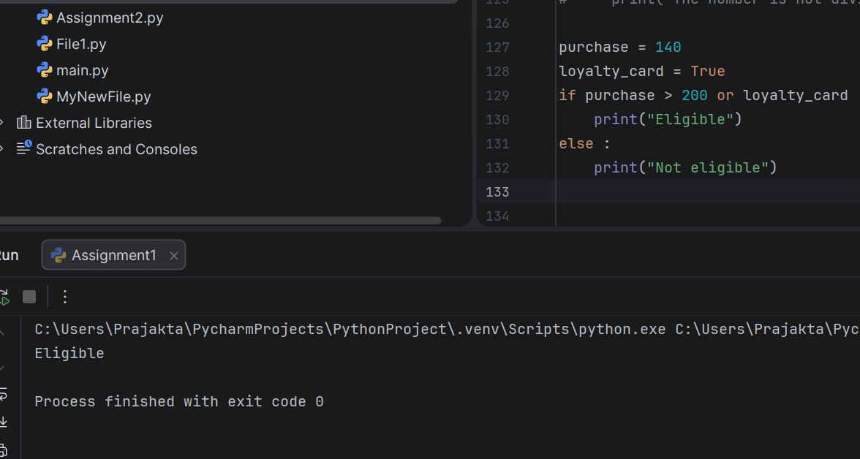
*************************************************************
23. Divisibility by 2 OR 3. Check if a number is divisible by either 2 or 3. Sample Data: Number: 4
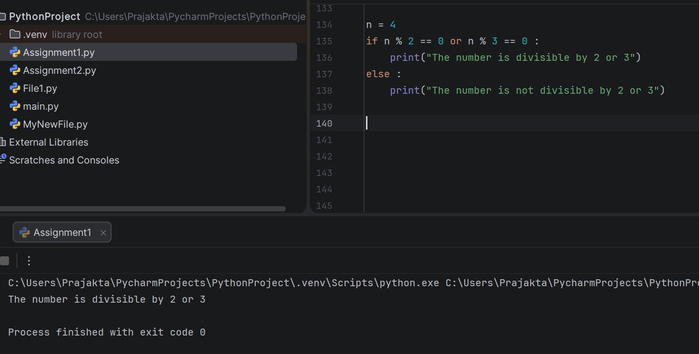
*************************************************************
24. Check for Positive AND Not Divisible by 3. Check if a number is positive and not divisible by 3. Sample Data: Number: 10.
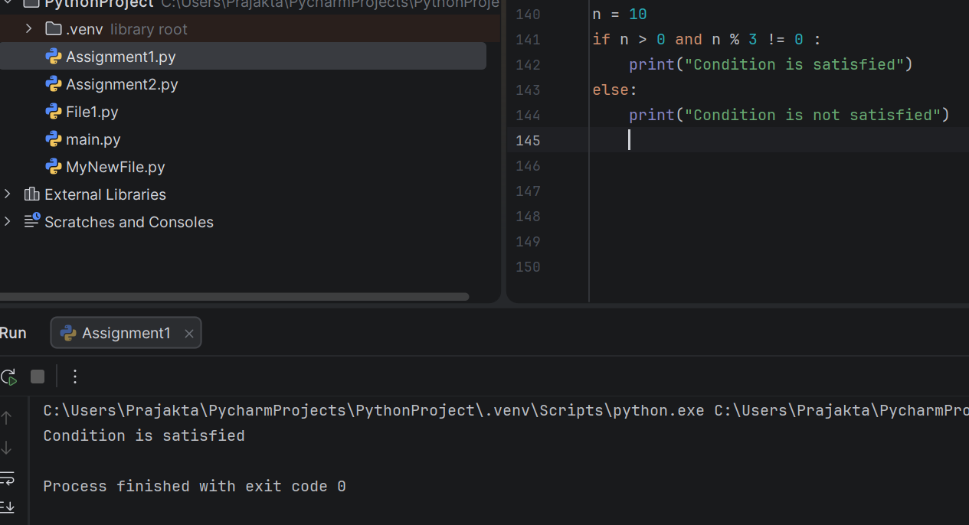
*************************************************************
25. Eligibility for Senior Discount AND Not a New Customer. Check if age > 65 and not a new customer. Sample Data: Age: 68, New Customer: false
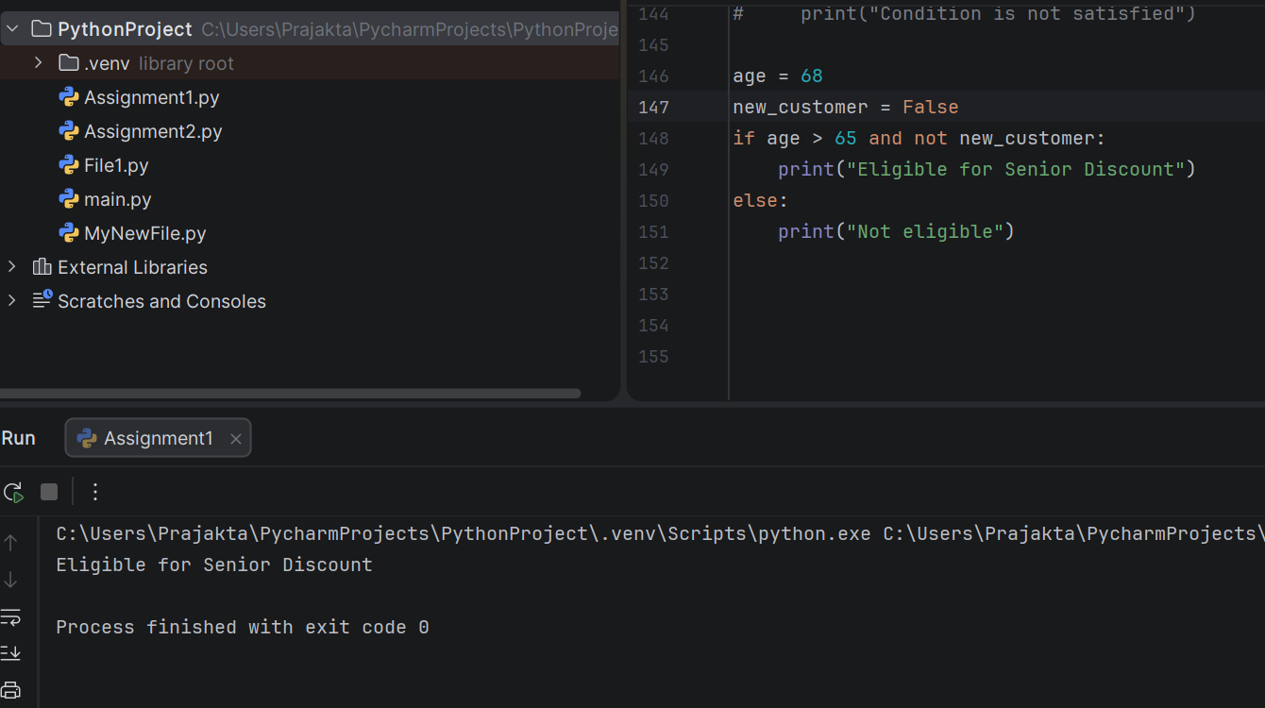

*************************************************************
26. Check for Odd OR Prime Number. Check if a number is odd or prime.
Sample Data: Number: 9
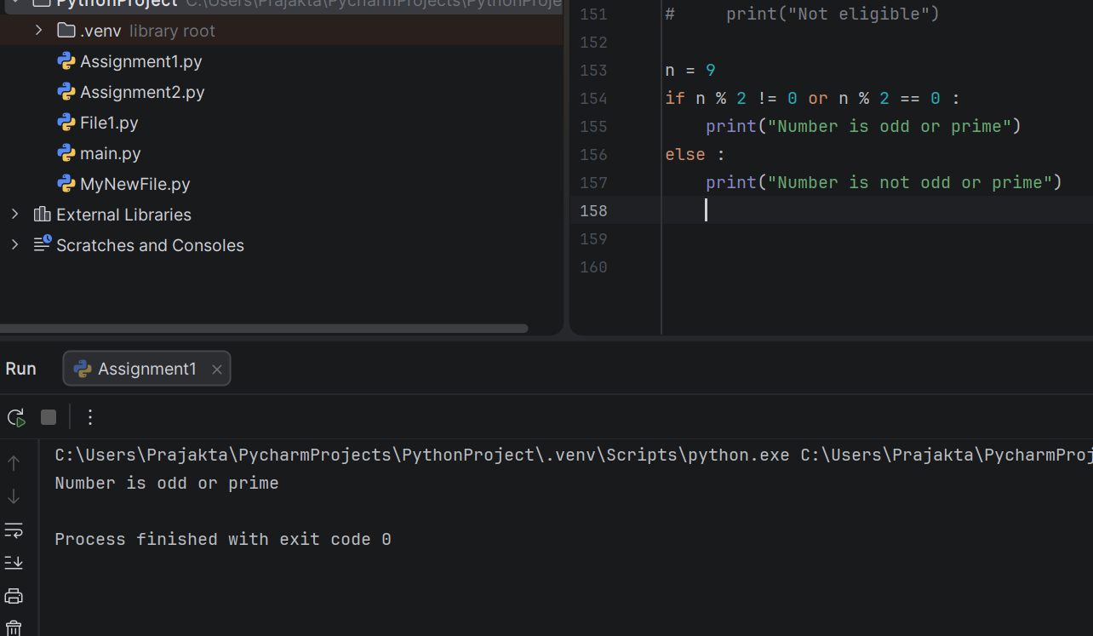
*************************************************************
27. Eligibility for Discount AND Free Shipping. Check if purchase > 150 and > 100.
Sample Data: Purchase Amount: 180
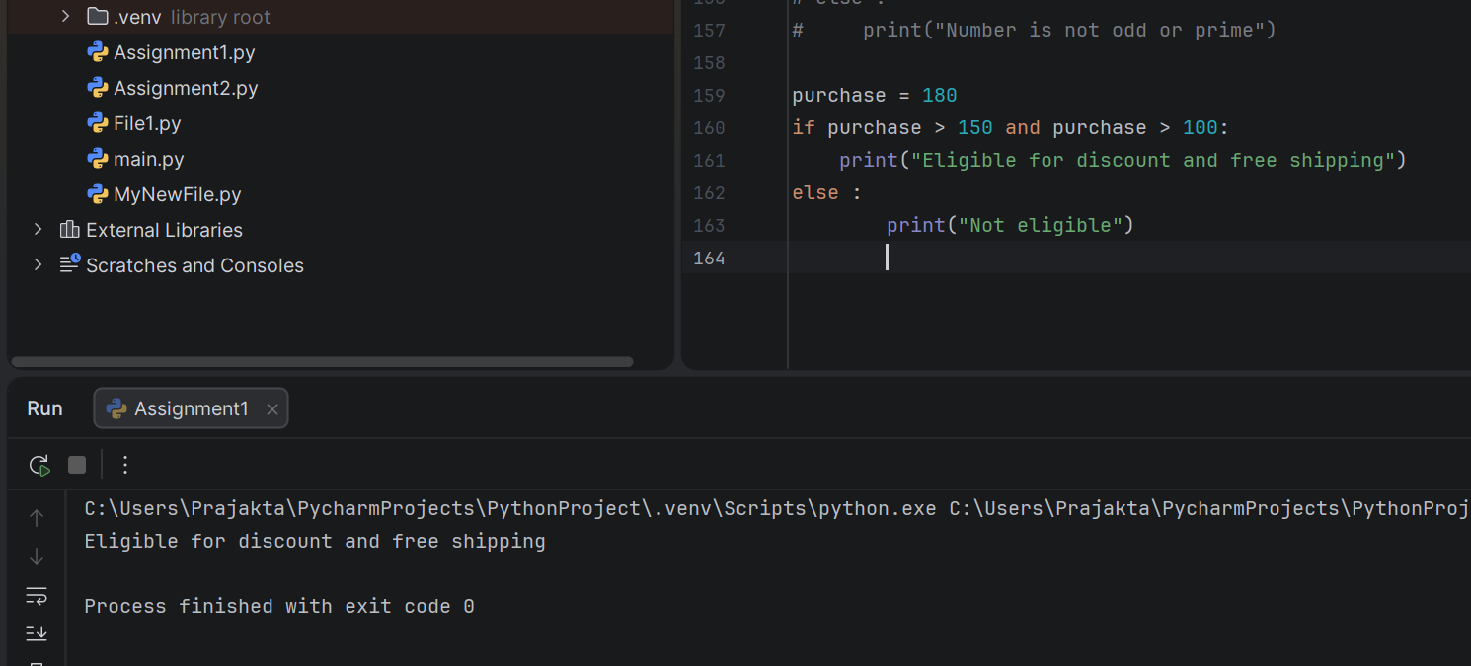
*************************************************************
28. Check for Non-Negative AND Not Divisible by 7
Check if a number is non-negative and not divisible by 7.
Sample Data: Number: 9

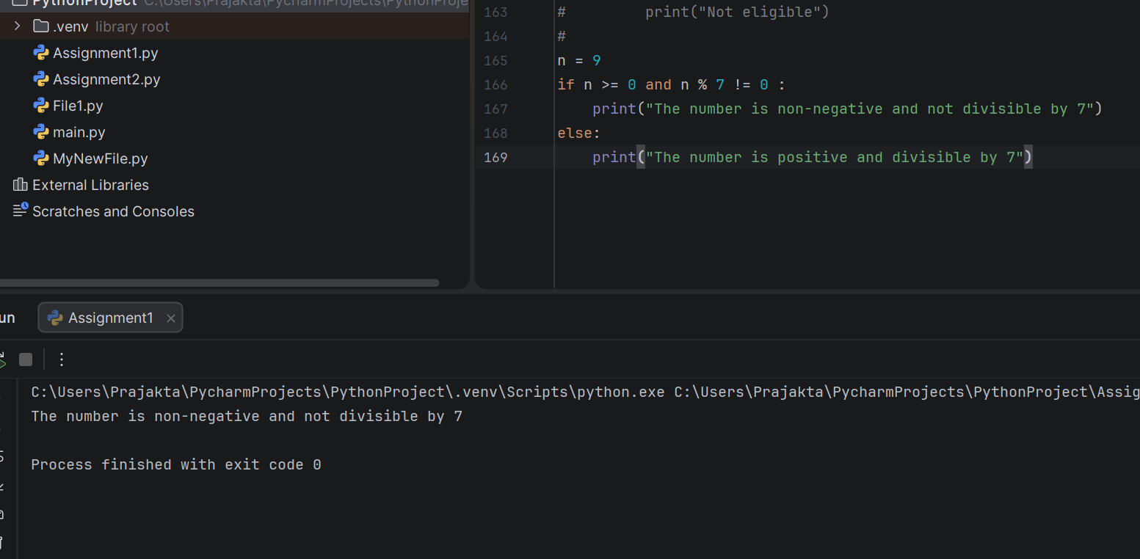
*************************************************************
29. Eligibility for Student Discount OR Free Trial
Check if age < 25 or free trial is true.
Sample Data: Age: 27, Free Trial: true
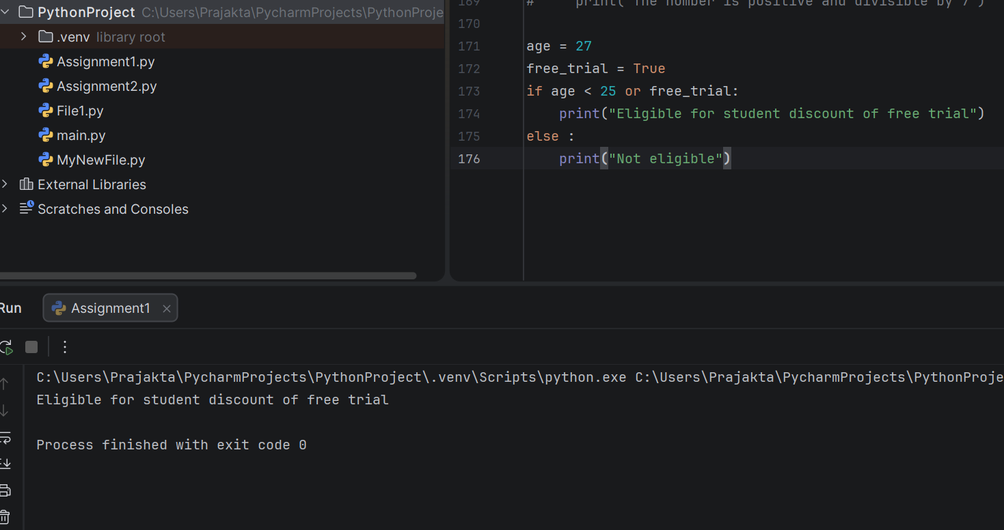
*************************************************************
30. Check for Divisibility by 4 OR 6
Check if a number is divisible by either 4 or 6.
Sample Data: Number: 12



